

**Wildlife Project**

By:

Devomech Solutions Pvt. Ltd.

Date: 19-04-2023

# Current Progress:

* Decoded the payload for recording device name / prefix, and verified the results from mobile app.



* Created a TLS (transport layer Security) based MQTT broker, and used TLS certificate to send data to a private MQTT broker on secure port.
* Created topic for every data string and subscriber each topic on MQTT web client.
* Tested the code on real hardware.

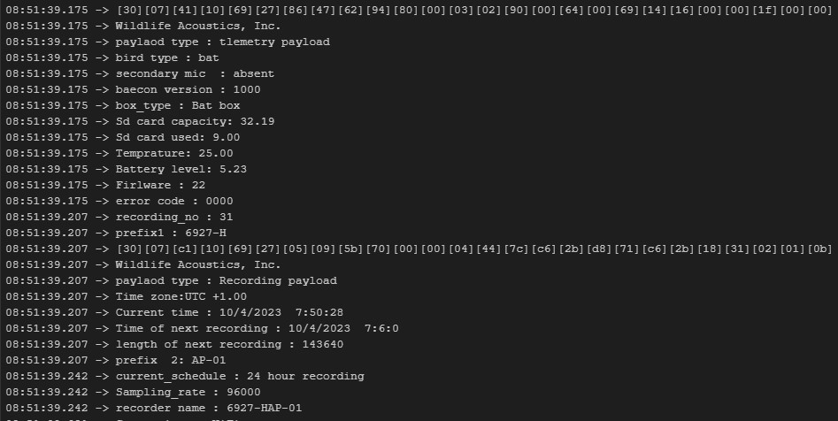

Figure 1 final payload decoded

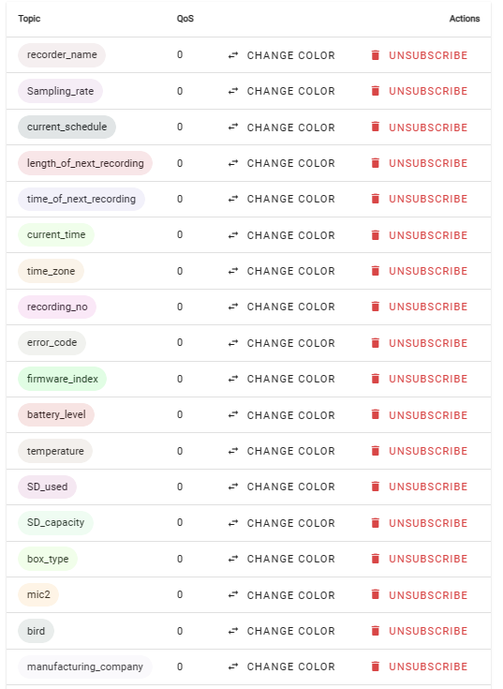

Figure 2 Subscribed Topics

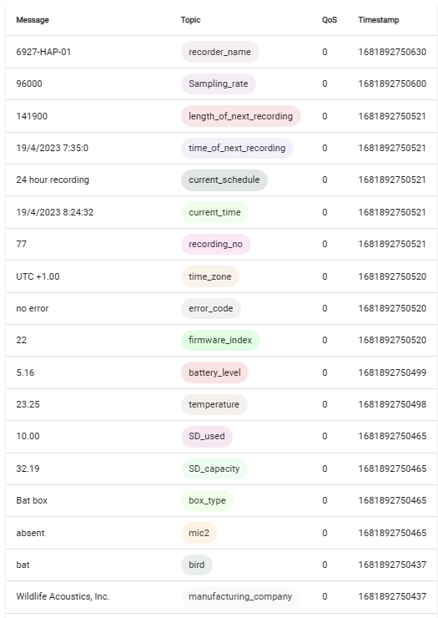

Figure 3 Web based client for MQTT broker

# Task for next week

* Currently the device is working on Wi-Fi network, connect the device to the cellular network using GSM and test the code.
* Use RTC to send data once a day, and verify.